Web Application Project: To-do list

Features: Add items on to-do list. Check box indicating completed or not.
Basic Components:
- check box to indicate task completion. Check must save
- ability to add new tasks
- ability to remove old tasks
Optional Advanced Features
- user specific (login or IP?)
- keep list of completed tasks in different area
- datestamping at completion
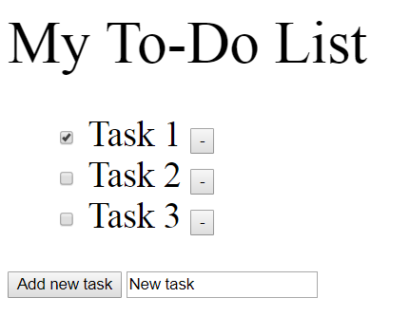
Need HTTP server – apache tomcat
Database – XML
Client side: html forms
server-side: java servlet/JSP
apache tomcat is used for hosting java web apps

Justification of servlets/jsp vs alternatives Django (python) or PHP or Ruby on Rails
- relevant to company
- I am unfamiliar
- faster than python and ROR, more widely used
- statically typed – less type mismatch errors
- PHP generally requires a framework and can be less flexible

https://www.ntu.edu.sg/home/ehchua/programming/howto/Tomcat_HowTo.html
configuring tomcat – port is 9999
did not enable automatic reload
-added PATH environmental variable for Java

Loading the webpage should load tasks from xml
- also load checkboxes based on completion status
Pressing buttons should manipulate xml
xml should look something like this:
<TaskList>
<Task>
<Name>Take out trash</Name>
<Status>Complete</Status>
</Task>
<Task>
<Name>Wash laundry</Name>
<Status>Not Complete</Status>
</Task>
</TaskList>

Uses DOM to parse XML

Added buttons using forms. Forms direct to servlet URL to activate servlet. Servlet will edit xml and reload jsp

3 servlets: addTask, removeTask, markTask
addTask
- sends task name to servlet. Servlet will add nodes to xml and refresh jsp
removeTask
- sends task ID xml attribute to servlet. Servlet will remove nodes based on ID and refresh jsp
markTask
- sends task ID xml attribute to servlet. Servlet will change Complete xml tag to complete if currently not complete or to not complete if currently complete

Uses hidden form field parameter passing

Improvement:
improve css/Change button appearance/layout
Tidy up this document
add dynamic refresh in case URI changes
combine servlets into one and pass parameter

Potential Useful Features
- change priority
- Datestamping completion
- If no xml data, add message telling user to add tasks
- Host application online?

Testing:
- all servlets work properly and user is prevented from entering blank task
- try to break input box

